**ARDUINO PROJECT 1:**

**(4 WAY TRAFFIC CONTROLLER)**

*Explanation:*

* Generally there are 3 leds used for each lane in a 4 way traffic light,but I used 4leds for each lane with delays to optimize traffic system.
* Led specification:

1. 1st led=red(stop)
2. 2nd led=orange/yellow(get ready to start or stop)
3. 3rd led=green(indicates strict left turns of major lane)
4. 4th led=green(indicates straight and right turns with pedestrian movement)

* In the coding part 1st we’ve declared all Arduino pins used

Inside void setup.

* Logic inside void loop:
* Phase-1:1st the strict left turns of major lanes occurs.(led used-1st,3rd)
* Phase-2:Straight and right turns with pedestrian movements.(Led used-1st,4th)

The first two phases are with delays of 5seconds i.e total of 10 seconds of vehicle motion.

* Phase-3:All leds turn orange or yellow after 10 sec and glow upto 2/3seconds indicating get ready to start or stop.(Led used-2nd)

Now the minor lanes turn open using green signals and major lanes get closed using red signals.

* Phase-4:3rd led turns ON for 5seconds of minor lanes for strict left turns then turns off after 10seconds.now the 4th led turns on indicating straight and right turns with pedestrian movements.
* Phase-5:All lights turn orange and then again 1st phase starts like a loop.

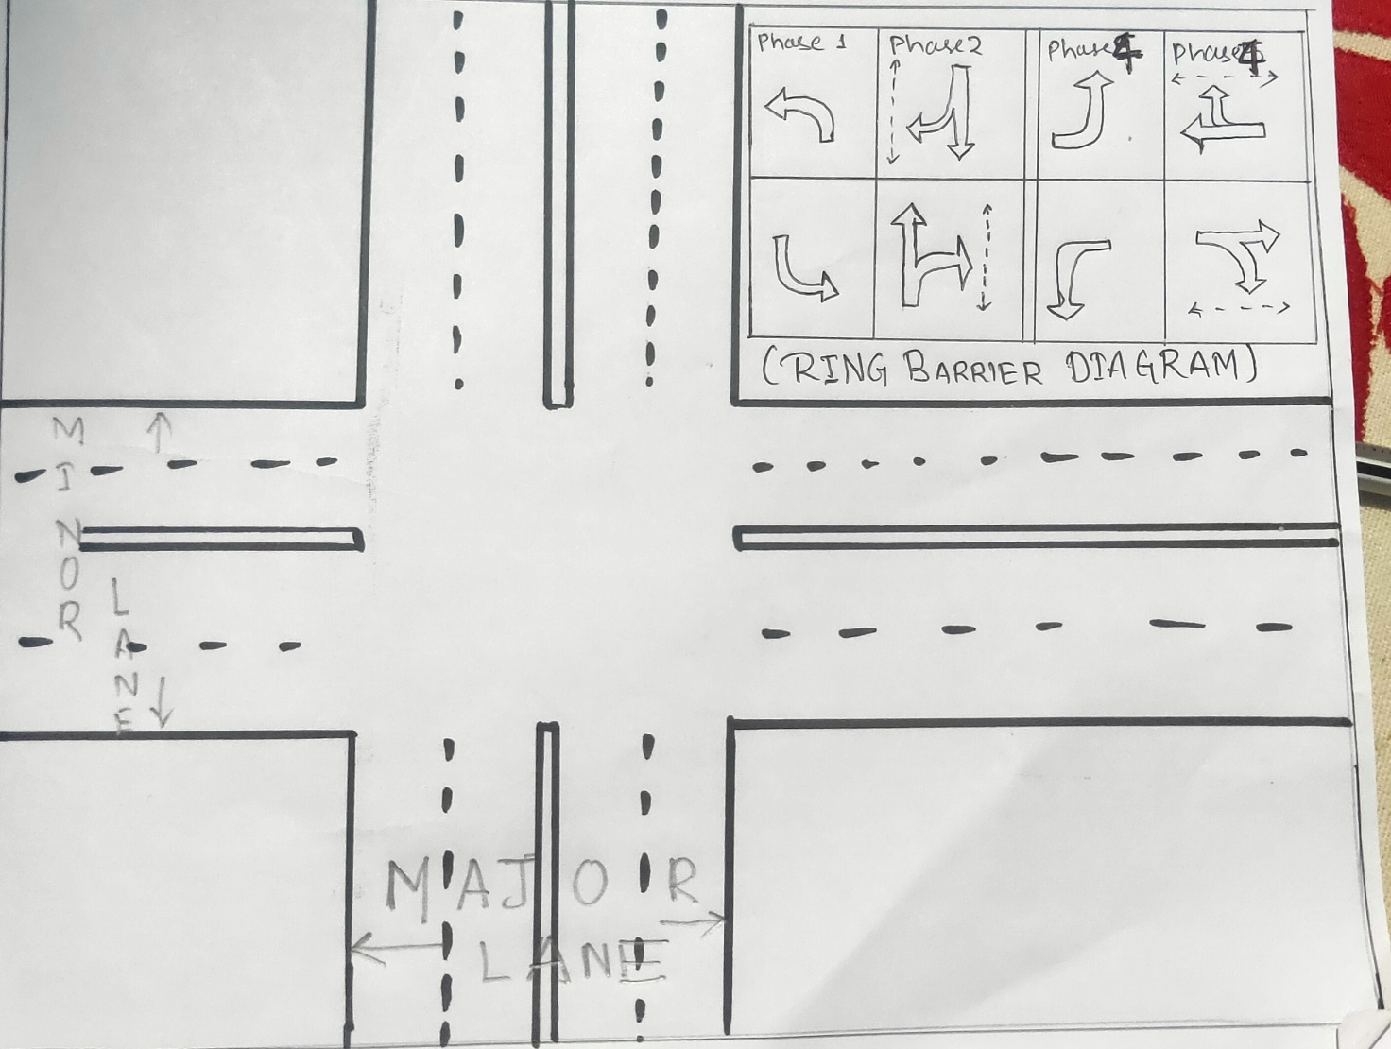

Figure 1

*Bibliography:*

* Youtube

1. Channel-Practical engineering.

Title-How do traffic signals work.

Publication date-MAY 14,2019

2.Channel-creative stuff.

Title-How to controle a lot of leds.

Publication date-2017

3.Channel-Electro Mentor.

Title-Arduino base 4 way traffic light system